**Python Operators Precedence Table**

|  |  |
| --- | --- |
| **Operator** | **Description** |
| ** | Exponentiation |
| ~, +, - | Complement, unary plus and unary minus |
| *, /, %, // | Multiply, divide, modulo and whole (floor) division |
| +, - | Addition and subtraction |
| >>, << | Right and left bitwise shift |
| & | Bitwise and |
| ^ ,| | Bitwise exclusive or and bitwise or |
| <=, < ,> ,>=, | Relational operators |
| <> ,== ,!= | Equality operators |
| = ,%= ,/= ,//= ,-= ,+= ,*=, **= | Assignment operators |
| is , is not | Identity operators |
| in not in | Membership operators |
| not , or , and | Logical operators |

**Python Relational Operators**

|  |  |  |
| --- | --- | --- |
| **Operator** | **Meaning** | **Usage** |
| > | Greater than | x > y |
| < | Less than | x < y |
| == | Equal to | x == y |
| != | Not equal to | x != y |
| >= | Greater than or equal to | x >= y |
| <= | Less than or equal to | x <= y |

**Python Logical Operators**

|  |  |  |
| --- | --- | --- |
| **Operator** | **Meaning** | **Usage** |
| and | True if both the operands are true | x and y |
| or | True if either of the operands is true | x or y |
| not | complements the operand | not x |

**Python Membership Operators**

|  |  |  |
| --- | --- | --- |
| **Operator** | **Meaning** | **Usage** |
| in | Check to see if value is in the sequence | 5 in [2,5,3,7] |
| not in | Check to see if value is not in the sequence | 5 not in [2,5,3,7] |

**Complete Precedence Table**

The following table shows the complete precedence of Python Operators: Highest to Lowest

|  |  |
| --- | --- |
| **OPERATOR** | **DESCRIPTION** |
| **()** | **Parenthesis (grouping)** |
| **f(args...), x[i:i], x[i], x.attr** | **Function call, slicing, subscript, dot** |
| **\*\*** | **Exponentiation** |
| **+, -, ~** | **Unary Positive, Unary Negative, bitwise NOT** |
| **\*, /, %** | **Multiplication, Division, Remainder** |
| **+, -** | **Addition, Subtraction** |
| **<<, >>** | **Shifts** |
| **&** | **Bitwise AND** |
| **^** | **Bitwise XOR** |
| **|** | **Bitwise OR** |
| **<, <=, >, >=, !=, ==, is, is not, in, not in** | **Comparisons, identity, membership** |
| **not** | **Boolean NOT** |
| **and** | **Boolean AND** |
| **or** | **Boolean OR** |
| **lambda** | **Lambda Expression** |

**Conditional if**

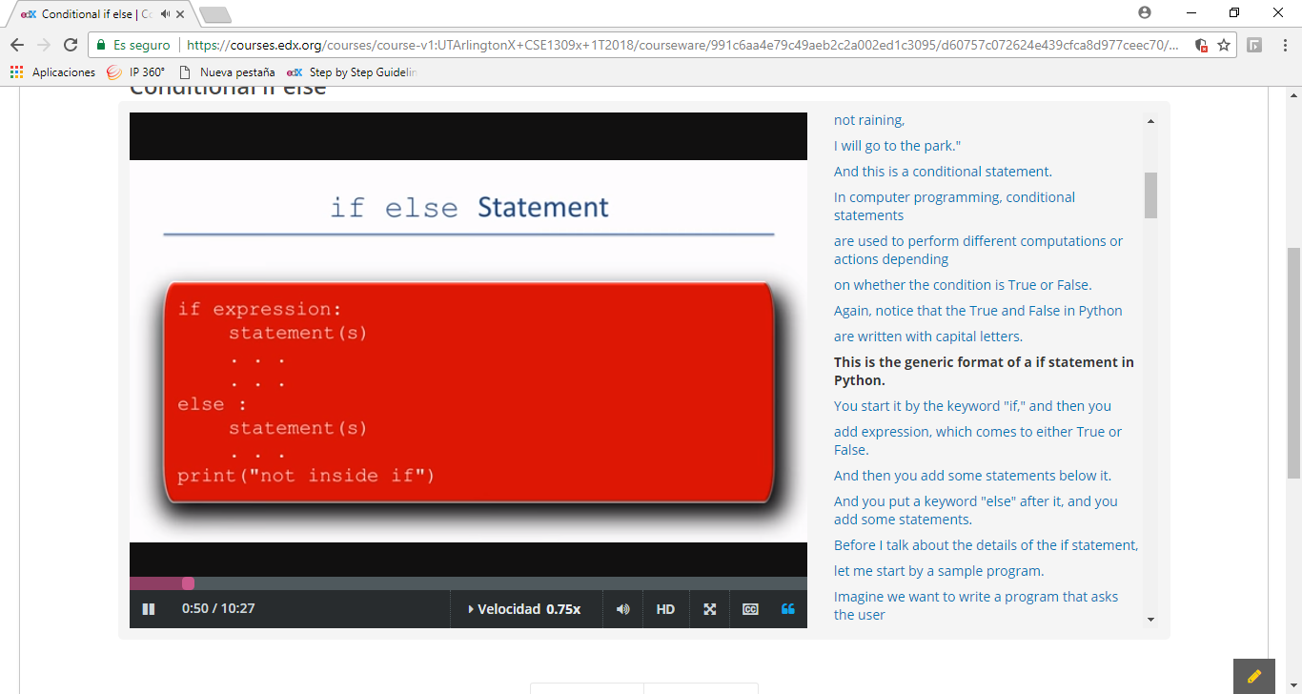

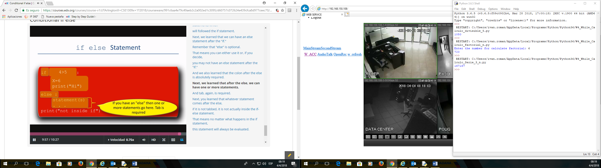

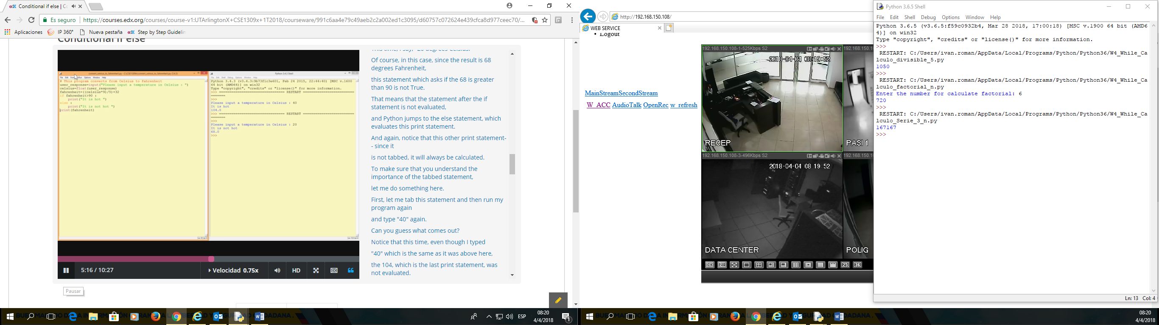

### Conditional if elif else

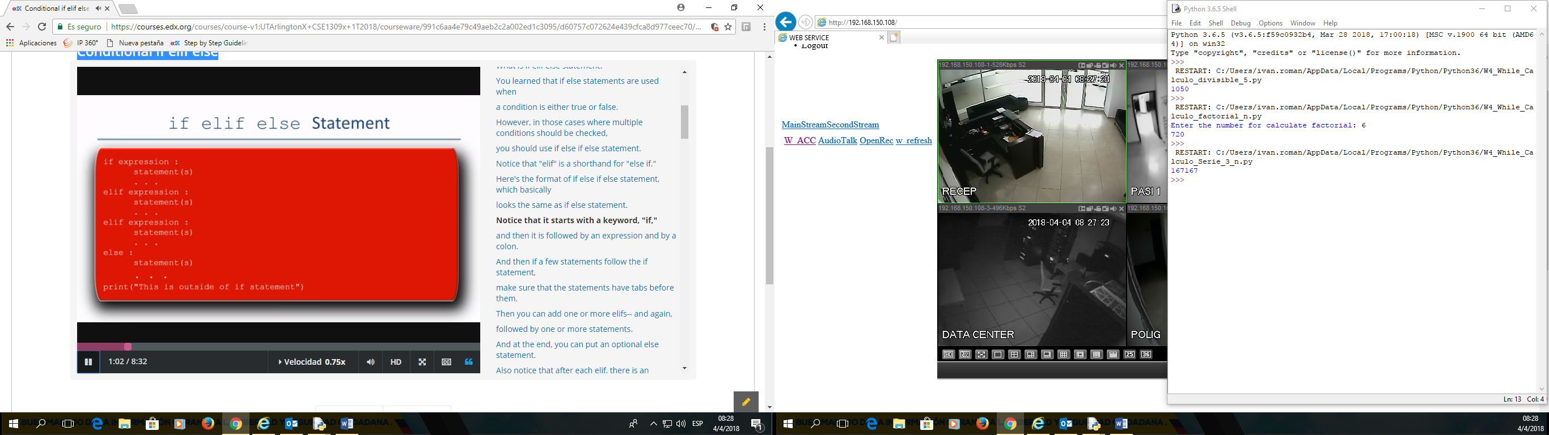

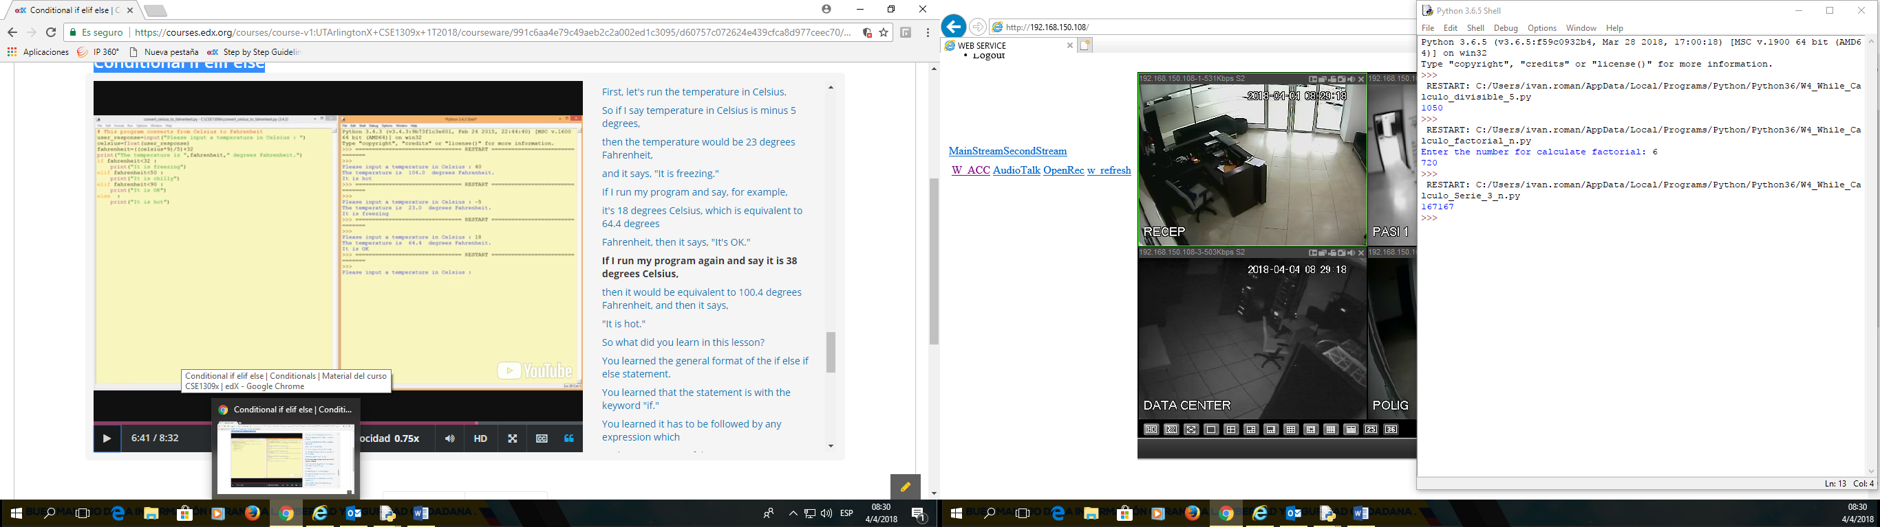

WHILE LOP

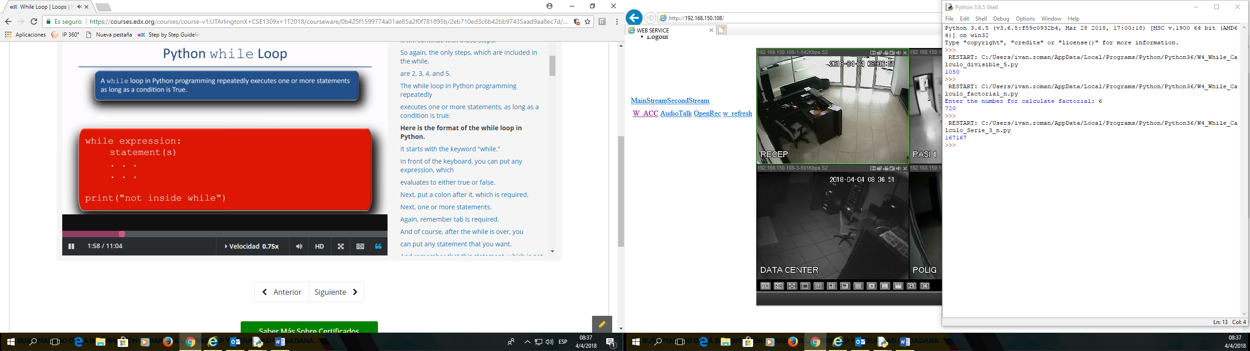

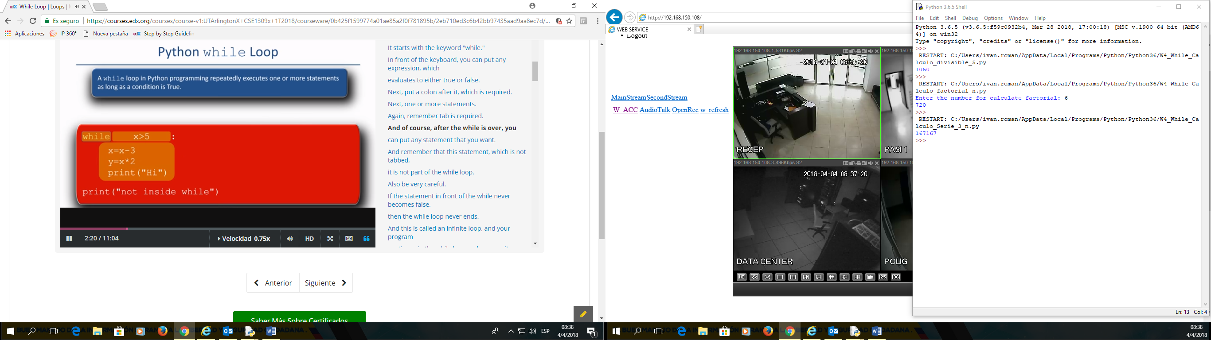

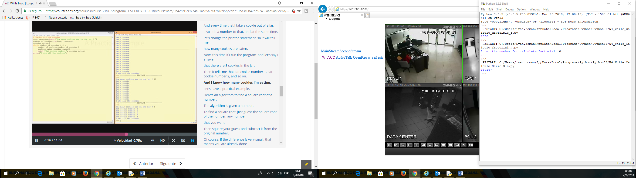

## For Loop

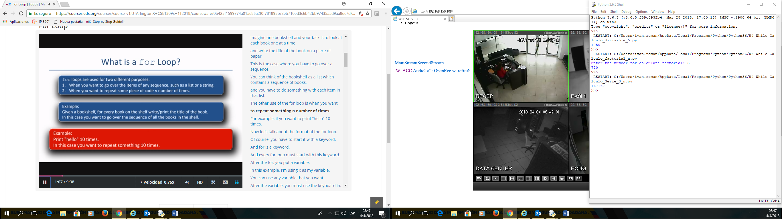

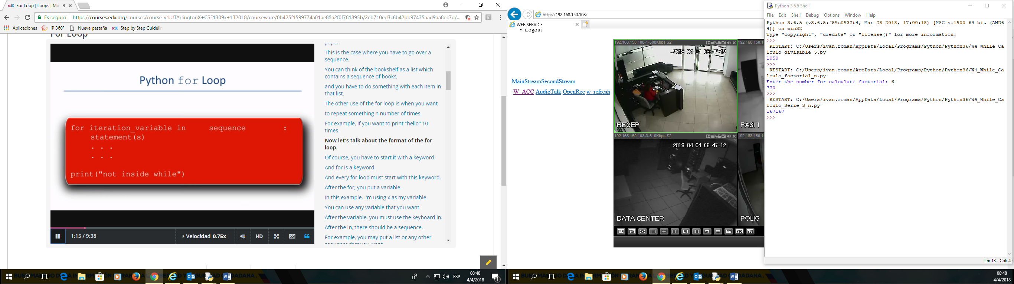

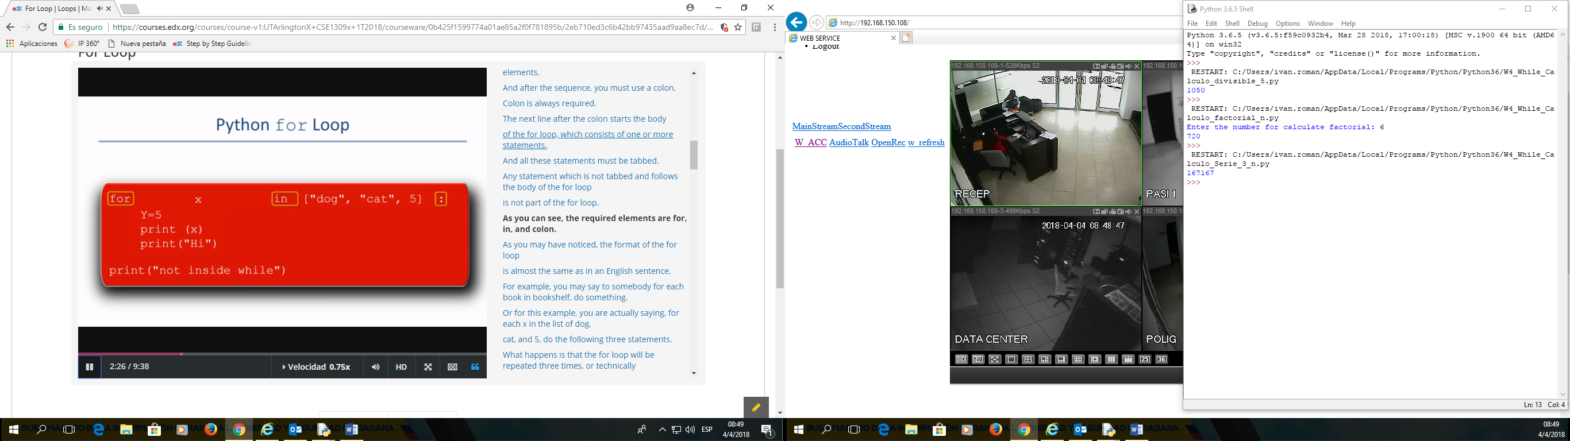

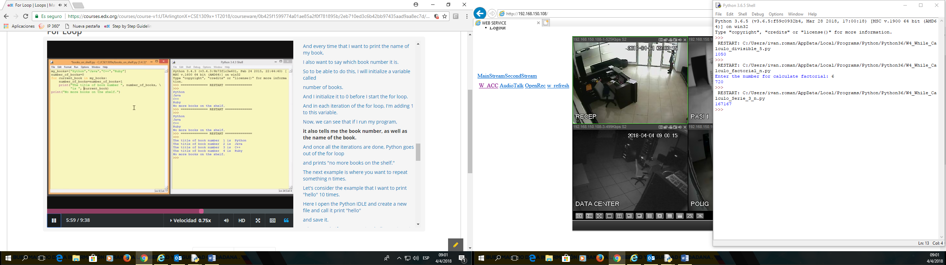

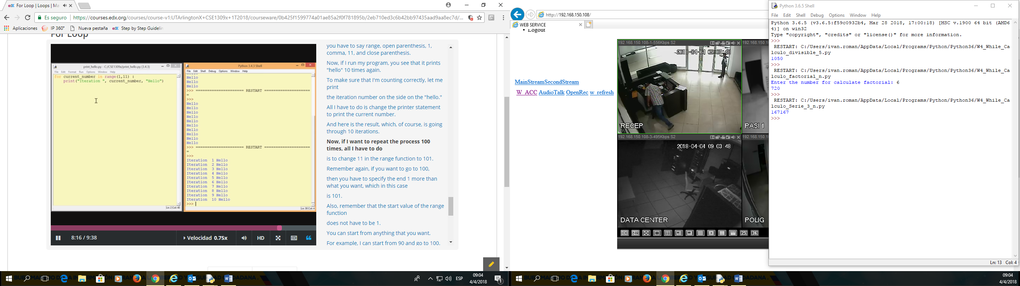

## Continue and Break

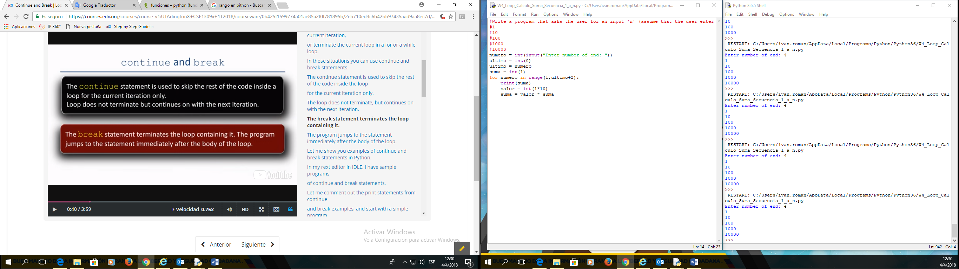

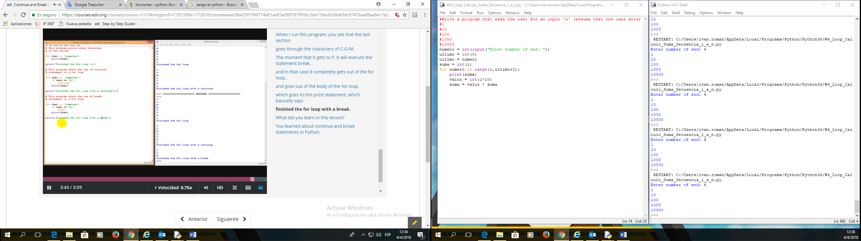

## Nested Loops

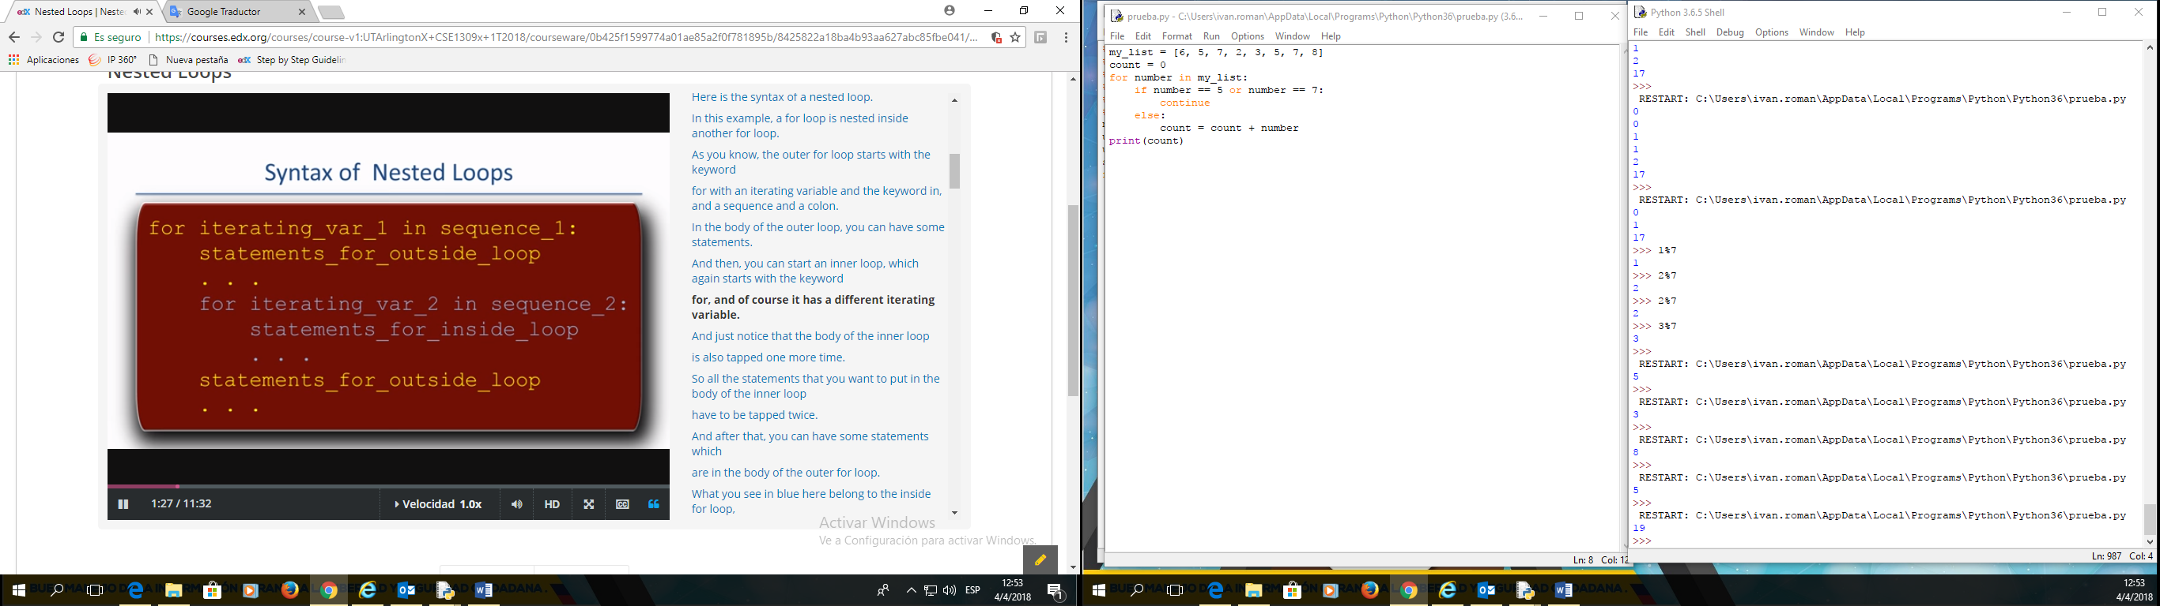

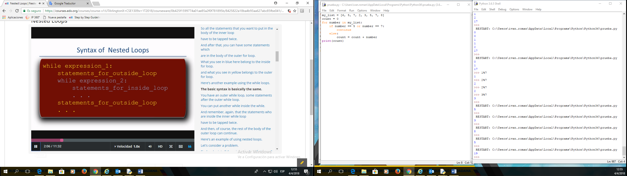

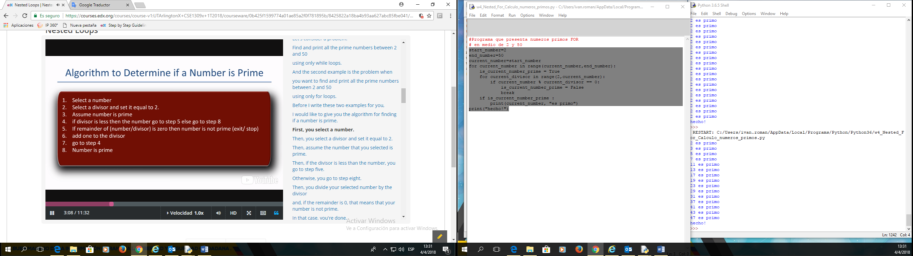

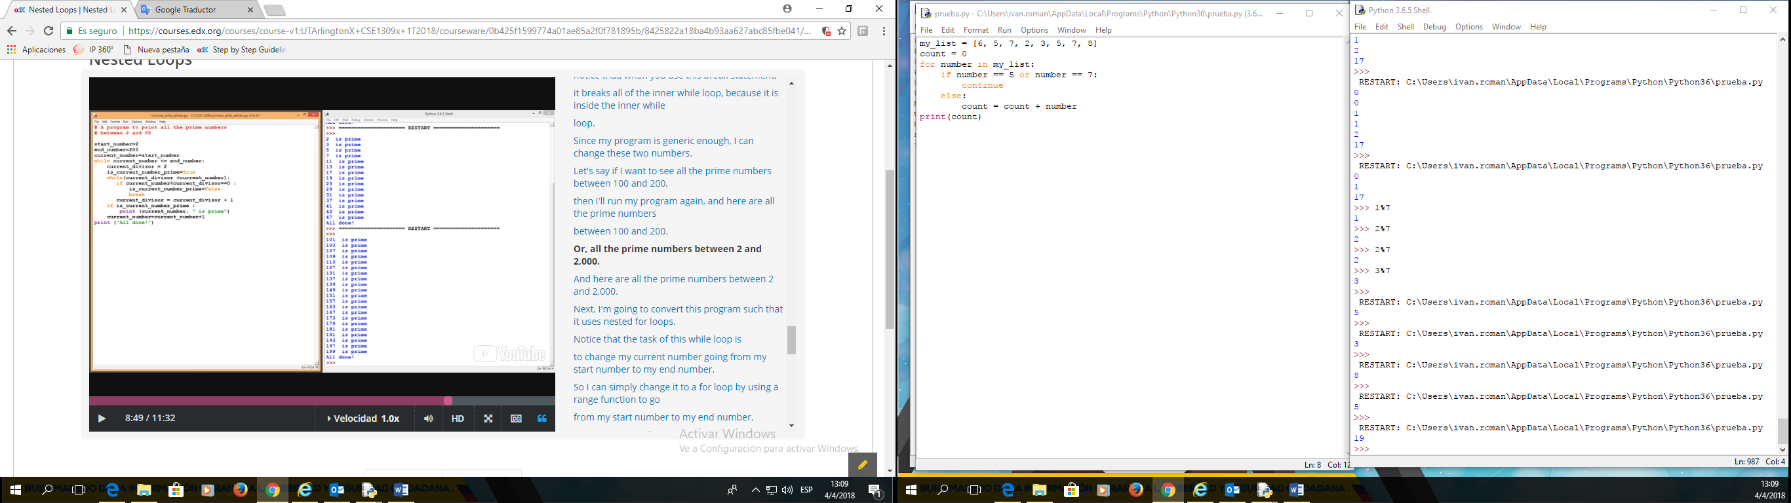

#Programa que presenta numeros primos **WHILE**

# en medio de 2 y 50

start_number=2

end_number=50

current_number=start_number

while current_number <= end_number:

current_divisor = 2

is_current_number_prime = True

while(current_divisor <current_number):

if current_number % current_divisor == 0:

is_current_number_prime = False

break

current_divisor = current_divisor + 1

if is_current_number_prime :

print(current_number, "es primo")

current_number = current_number + 1

print("hecho!")

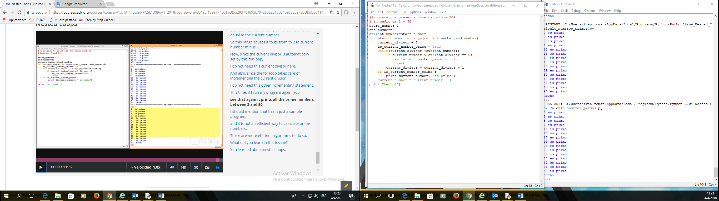

#Programa que presenta numeros primos **FOR**

# en medio de 2 y 50

start_number=2

end_number=50

current_number=start_number

for current_number in range(current_number,end_number+1):

is_current_number_prime = True

for current_divisor in range(2,current_number):

if current_number % current_divisor == 0:

is_current_number_prime = False

break

if is_current_number_prime :

print(current_number, "es primo")

print("hecho!")

## Functions

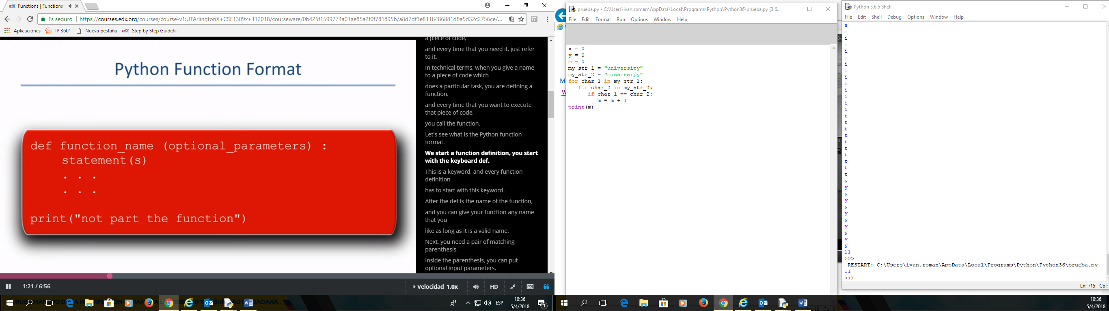

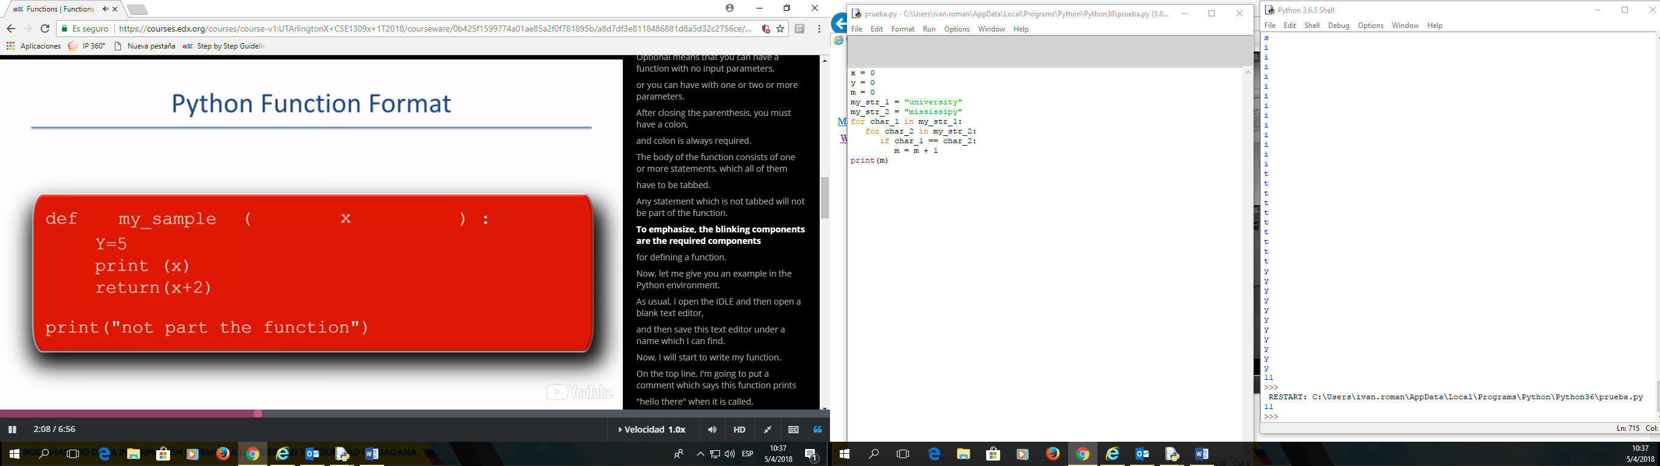

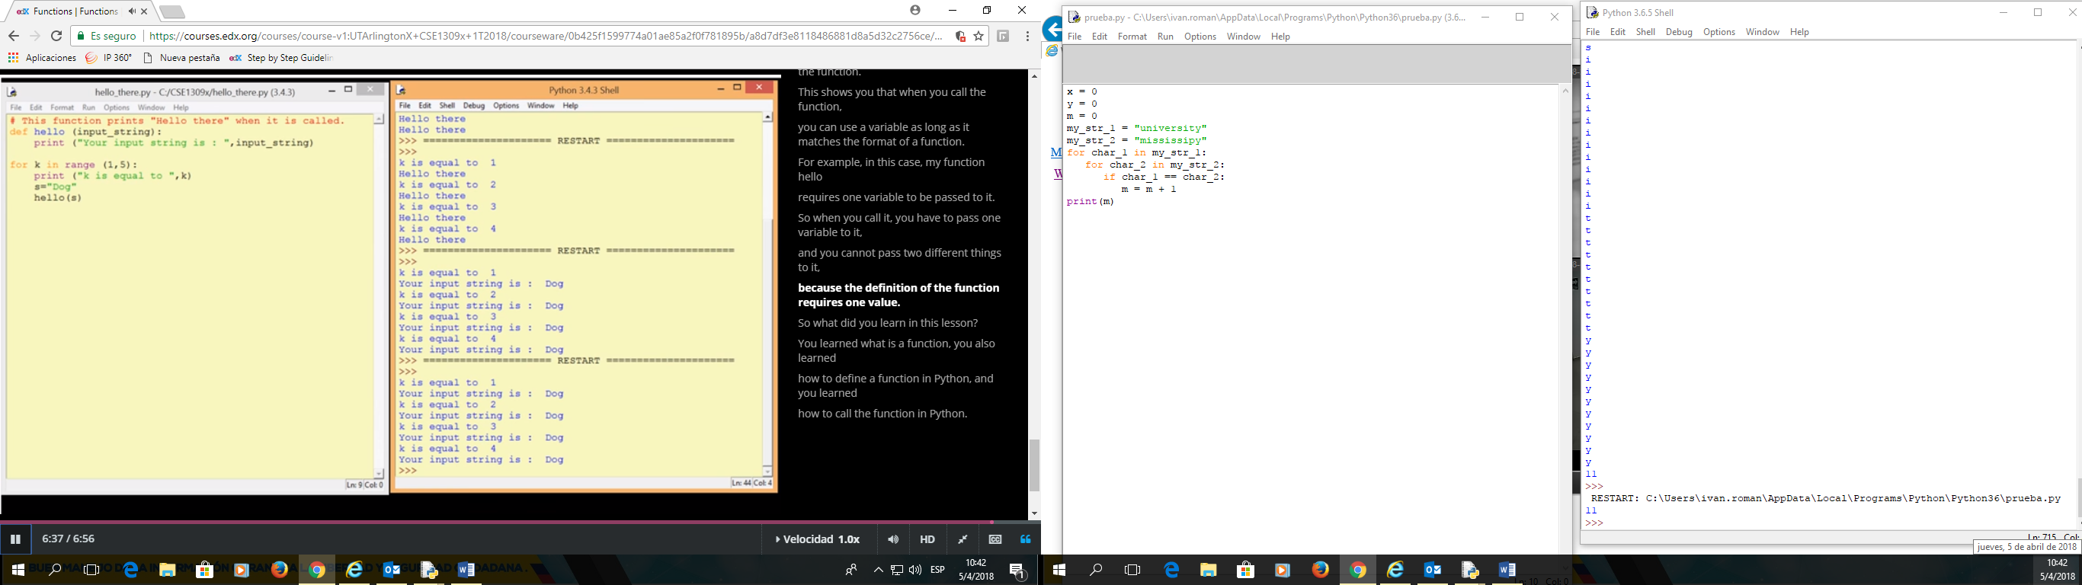

#This function print

def hello (input_string):

print ("Your input string is: ", input_string)

for k in range (1,5):

print ("k is equal to: ", k)

s="Dog"

hello(s)

**1. Nothing goes in, nothing comes out.**

Sometimes we need to do some task repeatedly and that task never changes. In this case, the function does not need any arguments (parameters) and it does not need to return anything.

**def** display_message():  
 print("**** PYTHON IS GREAT ****")  
 print("=============================")  
   
# Main Program #  
radius = 5  
print("The radius of the circle is: ", radius)  
display_message() # The function call   
  
circumference = 2*3.14*radius  
print("The circumference of the circle is:", circumference)  
display_message() # The function call

Note that the parentheses in the function call do not have any anything which means the function does not take any arguments. Also nothing is set equal to the function call i.e. the function call is on a line by itself which means it does not need to return anything. So basically, this function just keeps printing the same message every time it is called (Printing something is **not** the same as returning something). Even though, there is no **return** keyword in this function, it returns a **None**by default. 

This program produces:

The radius of the circle is: 5

**** PYTHON IS GREAT ****

=============================

The circumference of the circle is: 31.400000000000002

**** PYTHON IS GREAT ****

=============================

**2. Nothing goes in, something comes out.**

A great example of a function that does not receive anything but does return something is the following.

**import** random  
  
**def** report_random():  
 my_number = random.randint(20, 100)  
  **return** my_number  
  
# Main Program #  
a = report_random() # return a random int and assign it to a  
print("a is equal to ", a)  
b = report_random() # return a random int and assign it to b

print("b is equal to ", b)  
c = report_random() # return a random int and assign it to c

print("c is equal to ", c)

Notice that this function does not receive any arguments but each time we call this function it returns a random integer between 20 and 100 and assigns the returned value to the variable the function call was set equal to.

Sample run of this program produced: 

a is equal to 82

b is equal to 75

c is equal to 94

**3. Something goes in, nothing comes out.**

In this scenario, the function needs some arguments to do some task but it does not need to return anything.

**def** calculate_area(length, breadth):  
 area = length * breadth  
 perimeter = 2*length + 2*breadth  
 print("area is equal to", area)  
 print("perimeter is equal to", perimeter)  
  
# Main Program #  
calculate_area(10, 20)

Notice that this function does receive two arguments length and breadth and when we call this function, it calculates the area and perimeter of a rectangle and prints the results but it does not return anything! And again printing something is not the same as returning some value. The return value once again for this function is **None** as there is no **return** keyword.

Sample run of this program produces: 

area is equal to 200

perimeter is equal to 60

**4. Something goes in, something comes out.**

This is probably the most meaningful scenario where the function takes some arguments and performs some task using those arguments and returns some result as well.

**def** calculate_area(length, breadth):

area = length * breadth

perimeter = 2*length + 2*breadth  
 my_result = [area, perimeter] # put results in a list

return my_result # return the list

# Main Program #

my_list = calculate_area(10, 20) # two arguments are supplied   
print("The resulting list looks like:", my_list)

Sample run of this program produces: 

The resulting list looks like: [200, 60]

Note that we can return multiple things in python by separating them with a comma. For example instead of returning the results in a list we could have done the following:

return area, perimeter

In this situation, python would have returned the two values as a 'tuple', which would have looked like:

(200, 60)

We will discuss tuples in more detail later in the course.

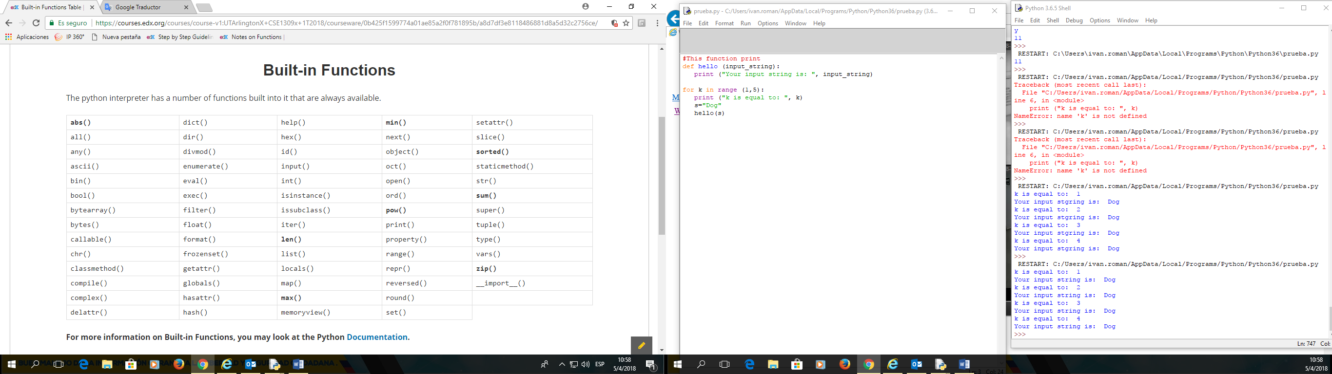

**Examples of Built in Functions**

**In this page, we will show examples of some of the built in functions.**

**abs**(x)

**This method returns the absolute value of a number. The argument maybe an integer or a floating point number. If the argument is a complex number, its magnitude is returned.**

**my_value = -11.55 # Notice that my_value is a negative floating point number**

**absolute = abs(my_value ) # Return the absolute value   
print("The absolute value is:", absolute)**

The result would be:

**The absolute value is: 11.55**

**len(x)**

**This method returns the length (the number of items) of an object. The argument maybe an sequence (such as a string, bytes, tuple, list, or range) or a collection (such as a dictionary, set, or frozen set).**

**my_list = ["abs", "len", 1, 2, "many", "more to come"] # Create a list called "my_list"**

**my_size = len(my_list) # Return length (the number of items) of my_list  
print("The length of my_list is:", my_size)**

The result would be:

**The length of my_list is: 6**

**max(iterable, *[, key, default])**

**max(arg1, arg2, *args[, key])**

**This method returns the largest item in an iterable or the largest of two or more arguments.**

**my_list = [-10, 12, 111, 32.3, 0, 4, 24] # Create a list called "my_list"**

**my_max1 = max(my_list) # Return the largest item in my_list  
my_max2 = max(my_list[0], my_list[-1]) # Return the largest among first & last element  
print("The largest item of my_list is:", my_max1) # Print my_max1 to see what was returned  
print("The larger among first and last item is:", my_max2)**

The result would be:

**The largest item of my_list is: 111**

**The larger among first and last item is: 24**

**min(iterable, *[, key, default])**

**min(arg1, arg2, *args[, key])**

**This method returns the smallest item in an iterable or the smallest of two or more arguments.**

**my_list = [10, -12, 11, 32.3, 1, 14, -5] # Create a list called "my_list"**

**my_min1 = min(my_list) # Return the smallest item in my_list  
my_min2 = min(my_list[0], my_list[-1]) # Return the smallest among first & last element  
print("The smallest item of my_list is:", my_min1) # Print my_min1 to see what was returned  
print("The smaller among first and last item is:", my_min2)**

The result would be:

**The smallest item of my_list is: -12**

**The smaller among first and last item is: -5**

**pow(x, y[, z])**

**This method returns x to the power y. The argument z is optional. If z is present then it returns x to the power of y, modulo z. Note that pow(x, y) is equivalent to using the power operator: x**y**

**x = 5 # initialize a variable x**

**y = 3 # initialize a variable y  
result = pow(x, y) # Return x to the power of y. Same as x**y  
print("The result of the operation is", result)**

The result would be:

**The result of the operation is 125**

**sorted(*iterable[, key][, reverse]*)**

**This method returns a new sorted list from the items in iterable.  
Has two optional arguments which must be specified as keyword arguments.**

**key: specifies a function of one argument that is used to extract a comparison key from each list element:  
 key=str.lower. The default value is None (compare the elements directly).**

**reverse: is a boolean value. If set to True, then the list elements are sorted as if each comparison were reversed.**

**# Lets sort the following list by the first item in each sub-list.   
my_list = [[2, 4], [0, 13], [11, 14], [-14, 12], [100, 3]]  
# First, we need to define a function that specifies what we would like our items sorted by  
def my_key(item):**

**return item[0] # Make the first item in each sub-list our key  
new_sorted_list = sorted(my_list, key=my_key) # Return a sorted list as specified by our key  
print("The sorted list looks like:", new_sorted_list)**

The result would be:

**The sorted list looks like: [[-14, 12], [0, 13], [2, 4], [11, 14], [100, 3]]**

**sum(*iterable*[*, start*])**

**This method sums *start* and the items of an iterable from left to right and returns the total. *start* defaults to 0. The iterables's items are normally numbers and the start value is not allowed to be a string.**

**my_list = [1, 2, 3, 4, 5] # Create a list**

**my_sum = sum(my_list) # Return the sum of the list  
print("The sum of my list is :", my_sum) # Print my_sum**

The result would be:

**The sum of my list is : 15**

**zip(*iterables)**

**This method returns an iterator of tuples, where the *i-*th tuple contains the *i-*th element from each of the argument sequence of iterables. The iterator stops when the shortest input iterable is exhausted.**

**x = [1, 2, 3, 4, 5] # Create a list**

**y = ['a', 'b', 'c'] # Note that this list only has 3 elements  
zipped = list(zip(x, y) ) # Return the zipped object as a list of tuples  
print("The result of the operation is:", zipped)**

The result would be:

**The result of the operation is: [(1, 'a'), (2, 'b'), (3, 'c')]**

## Functions Analogy

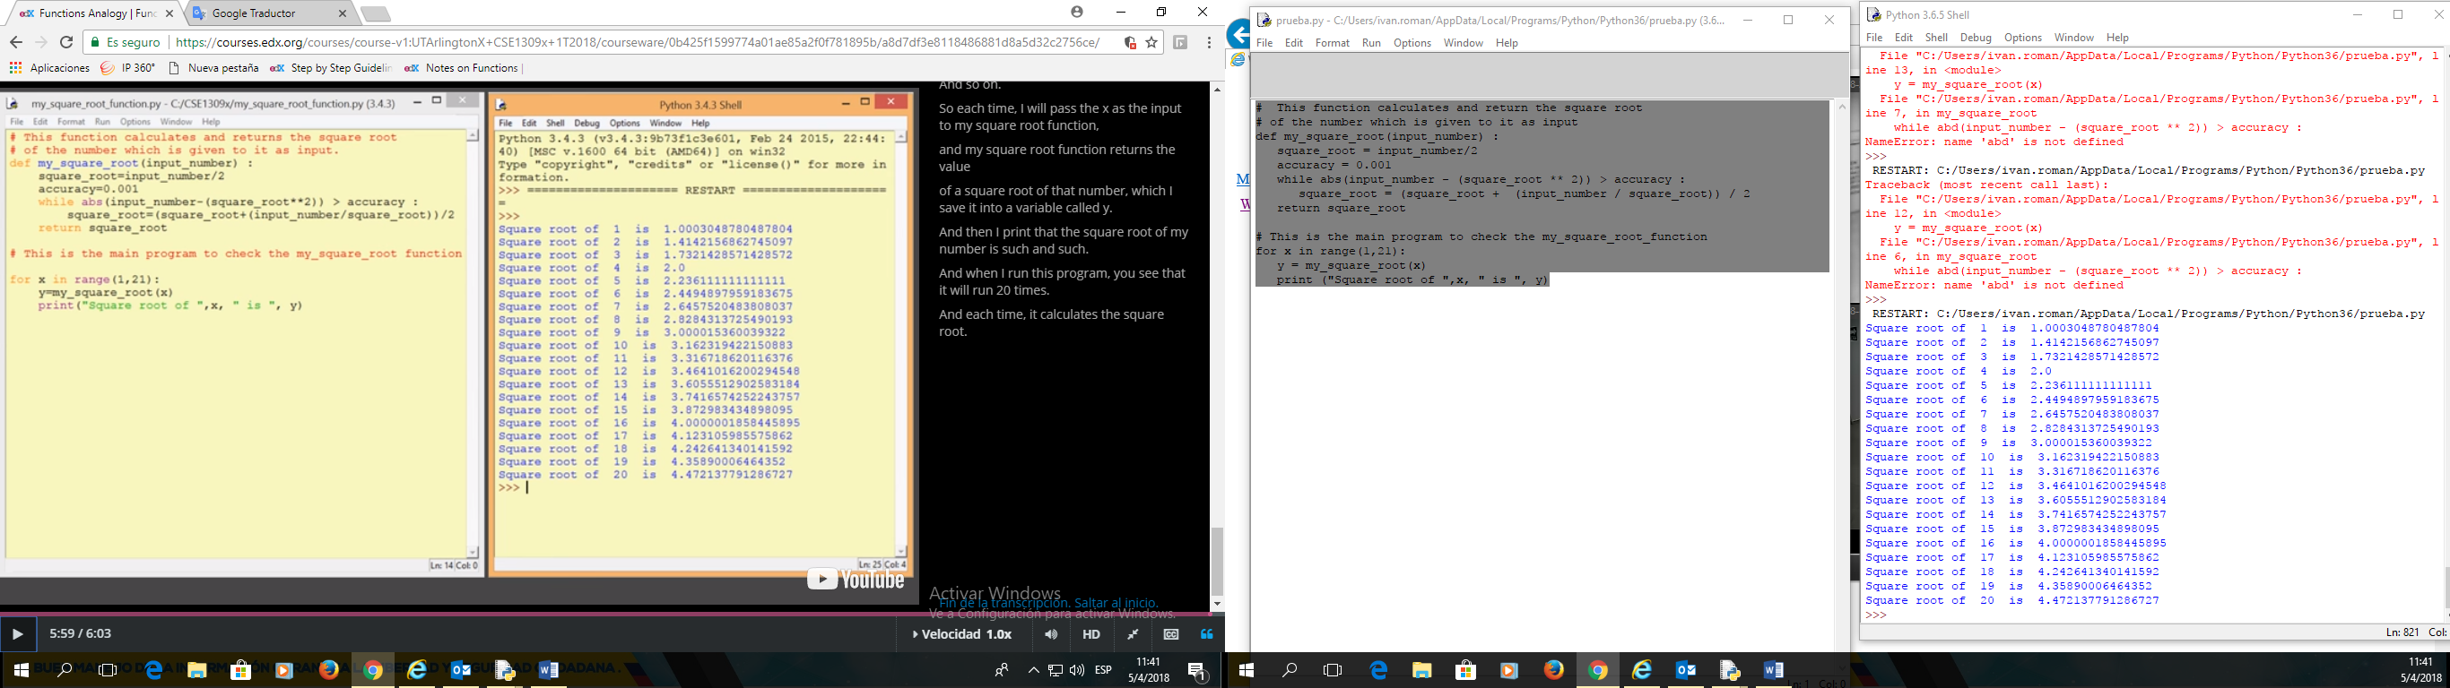

# This function calculates and return the square root

# of the number which is given to it as input

def my_square_root(input_number) :

square_root = input_number/2

accuracy = 0.001

while abs(input_number - (square_root ** 2)) > accuracy :

square_root = (square_root + (input_number / square_root)) / 2

return square_root

# This is the main program to check the my_square_root_function

for x in range(1,21):

y = my_square_root(x)

print ("Square root of ",x, " is ", y)

## MODULES

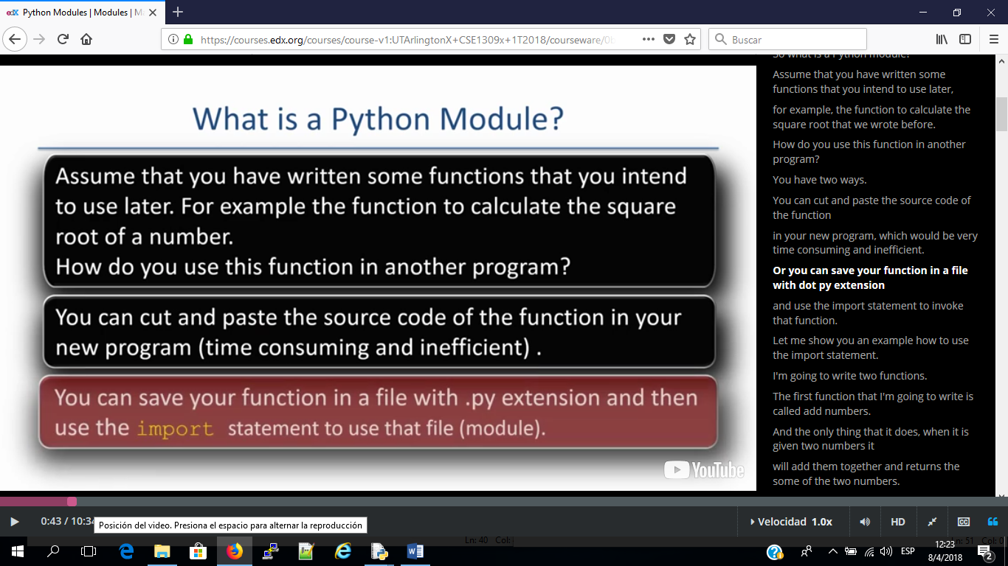

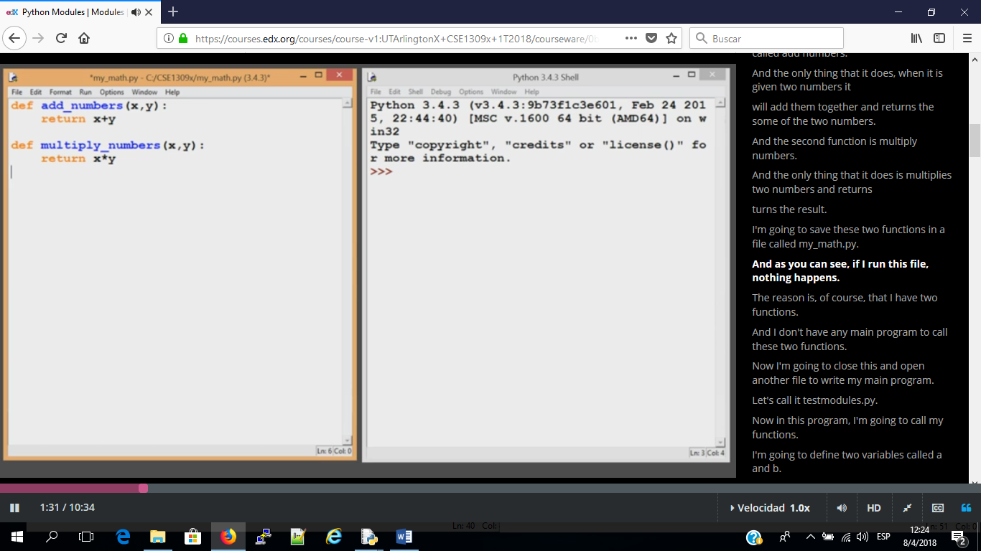

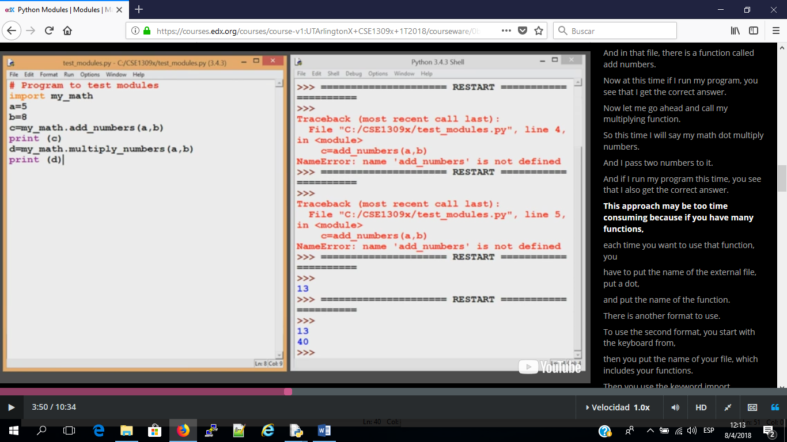

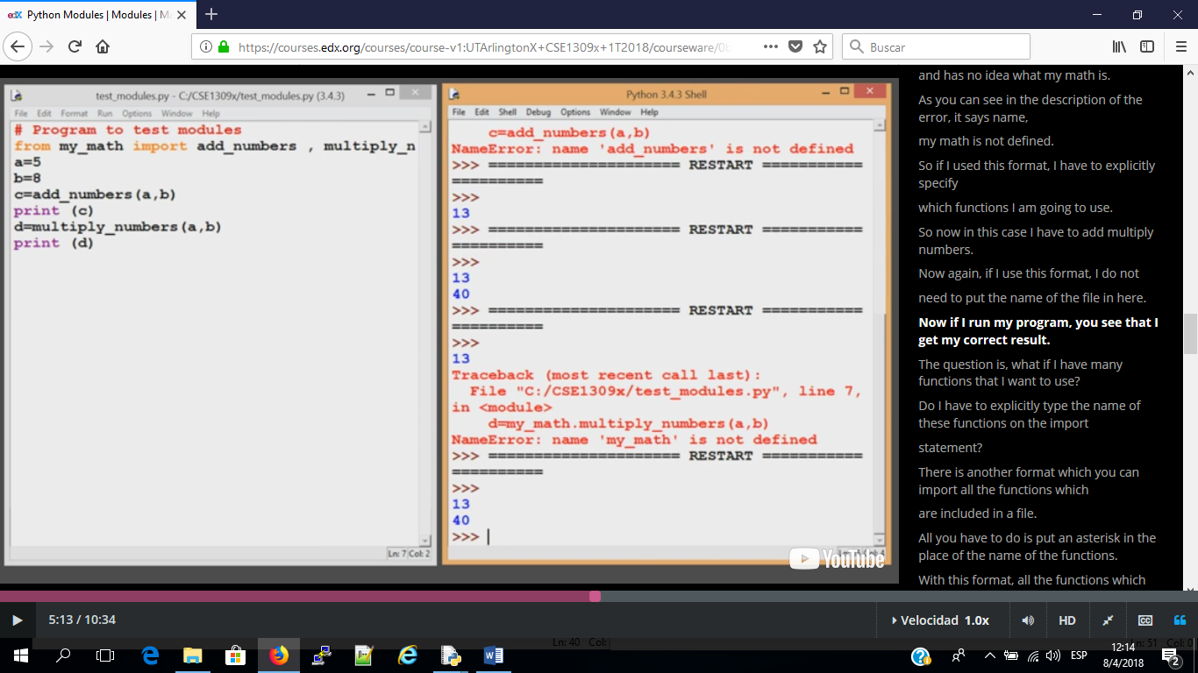

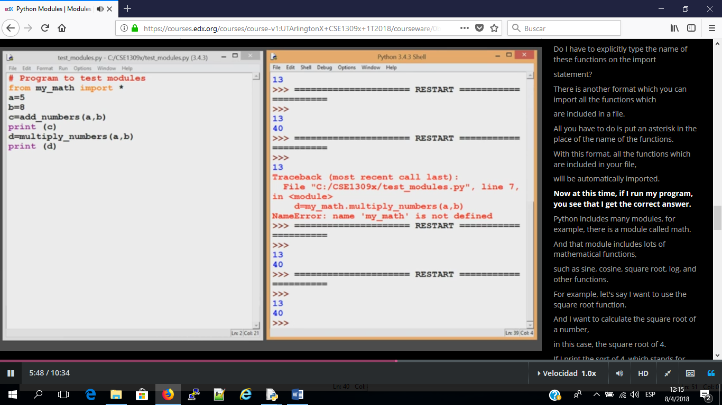

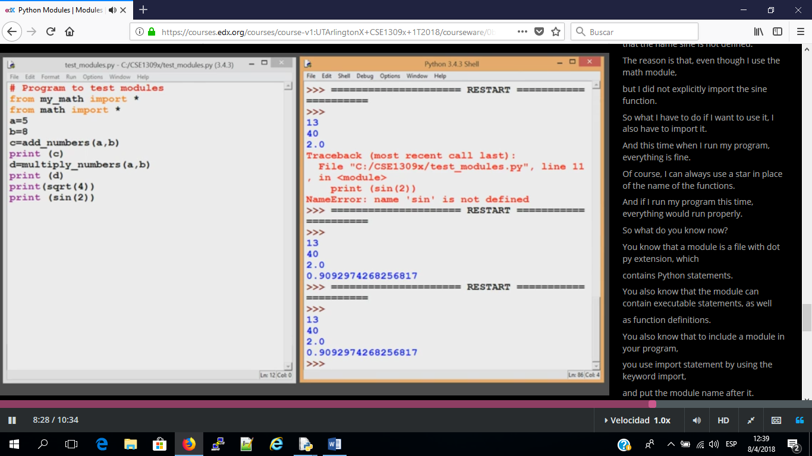

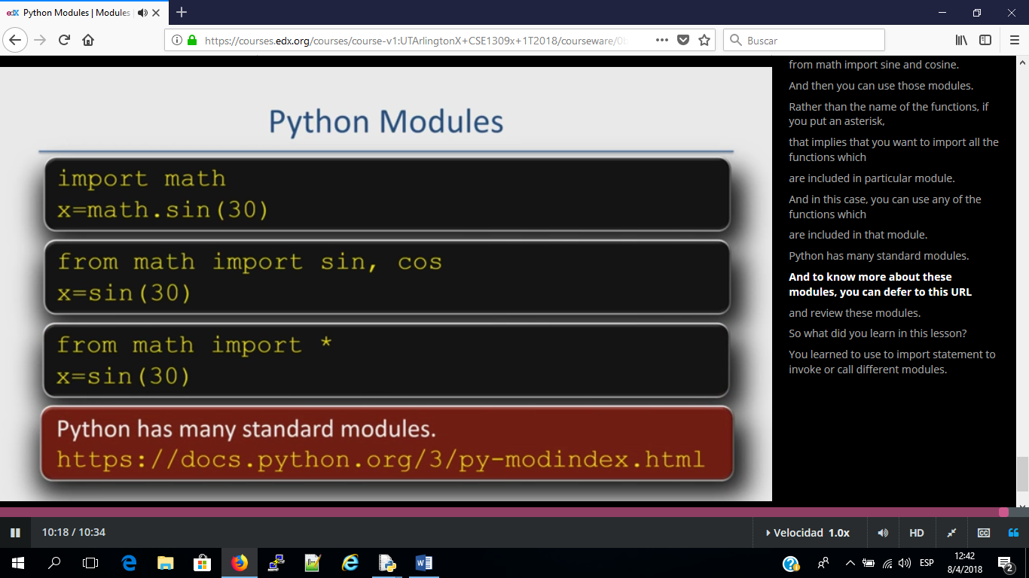

## LIST METHODS

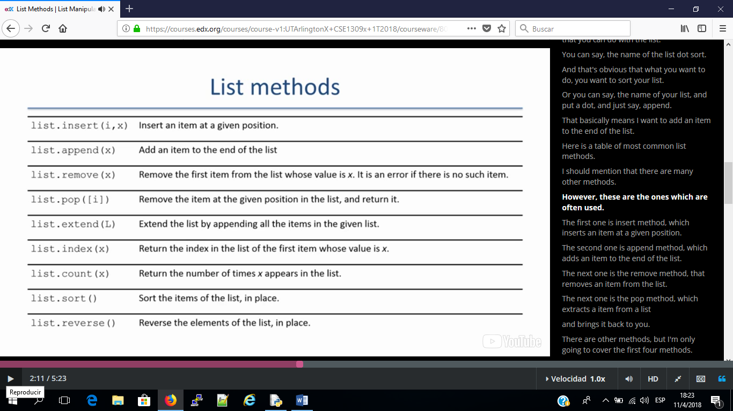

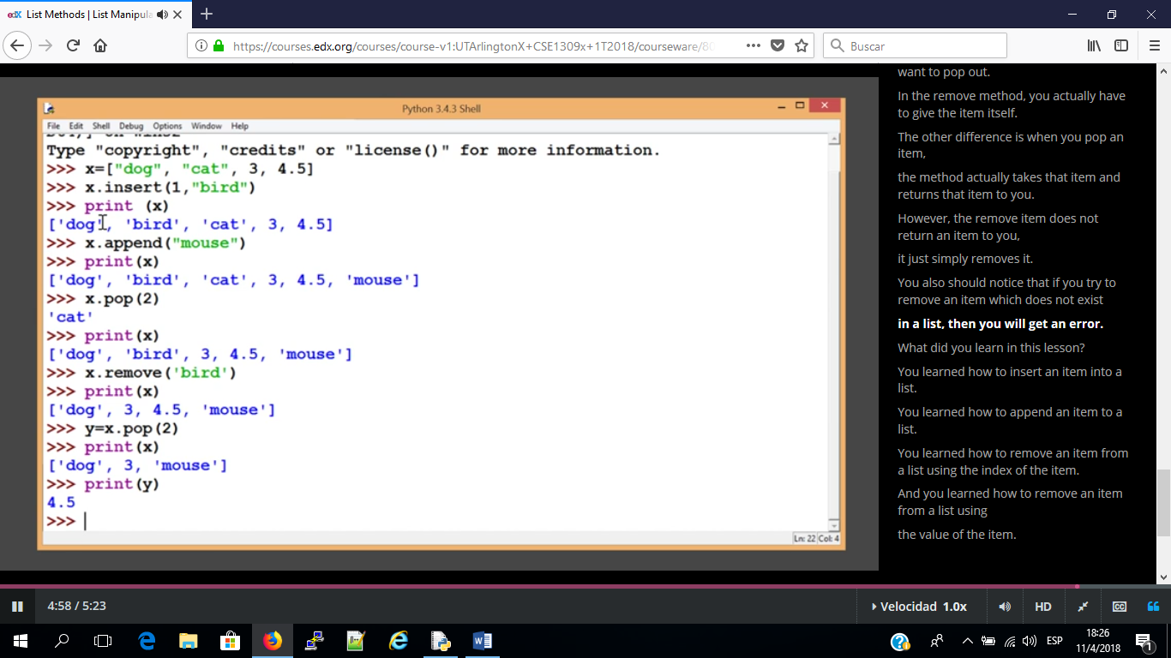

**Table of common methods for lists**

|  |  |
| --- | --- |
| list.append(x) | Add an item to the end of the list. Equivalent to a[len(a):] = [x]. |
| list.extend(L) | Extend the list by appending all the items in the given list. Equivalent to a[len(a):] = L. |
| list.insert(i, x) | Insert an item at a given position. The first argument is the index of the element to insert. |
| list.remove(x) | Remove the first item from the list whose value is x. It is an error if there is no such item. |
| list.copy() | Return a shallow copy of the list. Equivalent to a[:]. |
| list.pop([i]) | Remove the item at the given position and return it. If no index is specified, removes the last item. |
| list.clear() | Remove all items from the list. Equivalent to del a[:]. |
| list.index(x) | Return the index in the list of the first item whose value is x. It is an error if there is no such item. |
| list.count(x) | Return the number of times x appears in the list. |
| list.reverse() | Reverse the elements of the list in place. |
| list.sort(key=None, reverse=False) | Sort the items of the list in place (the arguments can be used for sort customization). |

**List Methods With Examples**

### list.****append****(x)

**This method adds an item to the end of the list.**  
**It is equivalent to doing: a[len(a):] = [x]**

**my_list = ["Tom", "Henry", "Mickey", "Juliet", "Sophie"] # Create a List**

**my_list.append("William") # Append "William" to the end of the list**

**print(my_list)**

The result would be:

**['Tom', 'Henry', 'Mickey', 'Juliet', 'Sophie', 'William']**

### list.****extend****(x)

**This method extends the list by appending all the items in the given list.**  
**It is equivalent to doing: a[len(a):] = L**

**list_one = [1, 2, 3, 4, 5, 6, 7] # This is the first list  
list_two = [10, 12, 14] # This is the second list**

**list_one.extend(list_two) # Extend list_one by appending all items of list_two**

**print(list_one)**

The result would be:

**[1, 2, 3, 4, 5, 6, 7, 10, 12, 14]**

### list.****insert****(i, x)

**This method inserts an item at a given position in the list. Where:**  
 **i : The index at which the item is to be inserted.**   
 **x : The item that is to be inserted.**

**my_list = ["Tom", "Henry", "Mickey", "Juliet", "Sophie"] # Create a List**

**my_list.insert(1, "Siddhartha") # Insert the string "Siddhartha" at index 1**

**print(my_list)**

The result would be:

**['Tom', 'Siddhartha', 'Henry', 'Mickey', 'Juliet', 'Sophie']**

### list.****remove****(x)

**This method removes the first item from the list whose value is x. It is an error if there is no such item.**

**my_list = ["Thou", "art", "precious!", "art", "gracious"] # Create a list  
my_list.remove("art") # Remove the first occurrence of the string "art"  
print(my_list)**

The result would be:

**['Thou', 'precious!', 'art', 'gracious']**

### list.****pop****([i])

**This method removes the item at the given position in the list and returns it.**   
**If no index is specified , list.pop() removes the last item in the list.**   
**Note that the square brackets around the i in the method signature denotes that the parameter is optional, not that you should type square brackets at the position.**

**my_list = ["Thou", "art", "precious!", "art", "gracious"] # Create a list  
my_item = my_list.pop(2) # Remove item at index 2 and return it  
print("The item that was popped was: ", my_item) # Print my_item to see what was returned  
print("my list now looks like = ", my_list)**

The result would be:

**The item that was popped was: precious!**

**my list now looks like = ['Thou', 'art', 'art', 'gracious']**

### list.****clear****()

**This method removes all the items from the list.**   
**It is equivalent to doing:**  
**del a[:]**

**my_list = [2, 3, 5, 7, 11, 13] # Create a list  
my_list.clear() # Remove all the items from the list  
print(my_list)**

The result would be:

**[]**

### list.****index****(x)

**This method returns the index in the list of the first item whose value is x. It is an error if there is not such item.**

**my_list = ["Python", "is", "awesome", "Java", "is", "Alright"] # Create a list  
my_index = my_list.index("is") # Return the index of the first "is"  
print("The item was first found at index:", my_index)**

The result would be:

**The item was first found at index: 1**

### list.****count****(x)

**This method returns the number of times x appears in the list**

**my_list = ["mew", "mew", "kitten", "mew", "mew"] # Create a list  
my_count = my_list.count("mew") # Return the number of times "mew" appears  
print("The number of times the item appeared was:", my_count)**

The result would be:

**The number of times the item appeared was: 4**

### list.****sor****t(key=None, reverse=False)

**This method sorts the items of the list in place. Note that this method does not return anything. (The arguments are optional and can be used for sort customization, see** [**sorted()**](https://docs.python.org/3/library/functions.html#sorted) **for their explanation.)**

**my_list = [5, 3, 6, 1, 2, 4, 7] # Create a list  
my_list.sort() # Sort the items of the list in place  
print("Sorted list looks like:", my_list)**

The result would be:

**Sorted list looks like: [1, 2, 3, 4, 5, 6, 7]**

### list.****reverse****()

**This method reverses the items of the list in place. Note that this method does not return anything.**

**my_list = ["zero", "one", "two", "three", "four", "five"] # Create a list  
my_list.reverse() # Reverse the items of the list in place  
print("Reversed list looks like:", my_list)**

The result would be:

**Reversed list looks like: ['five', 'four', 'three', 'two', 'one', 'zero']**

### list.****copy****()

**This method returns a shallow copy of the list.   
It is equivalent to doing:  
a[:]**

**original_list = ["zero", "one", "two", "three"] # Create a list  
copied_list = original_list.copy() # Copy the original list and return it.   
print("Copied list looks like:", copied_list)**

The result would be:

**Copied list looks like: ['zero', 'one', 'two', 'three']**

## LIST SLICING

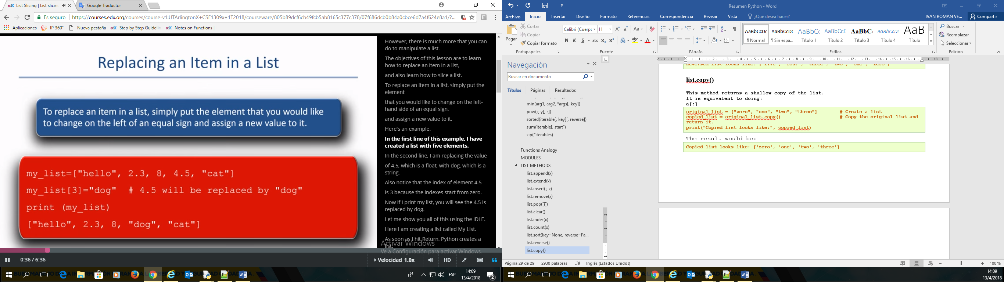

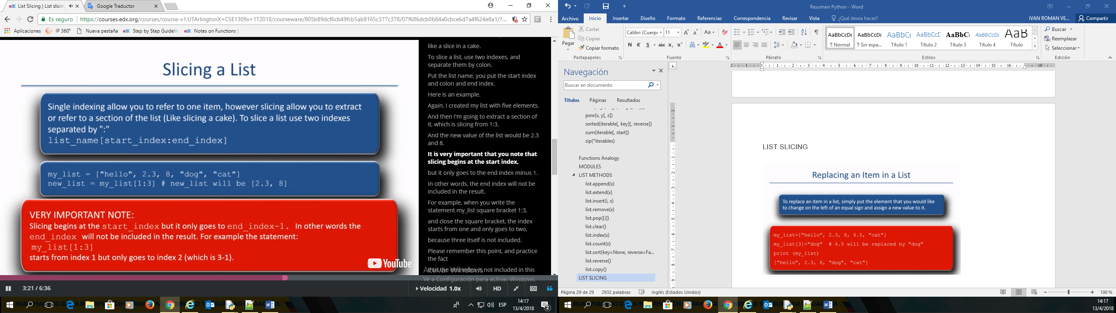

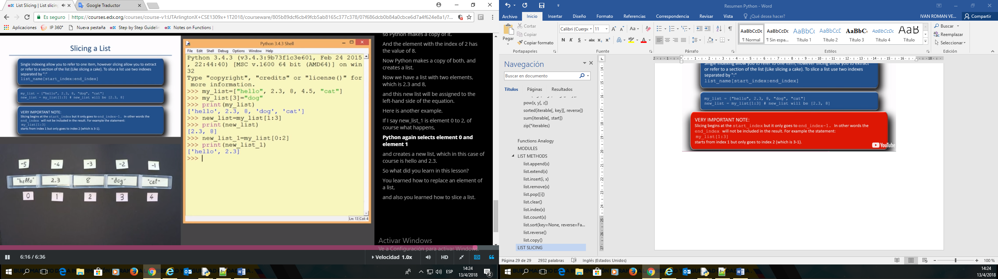

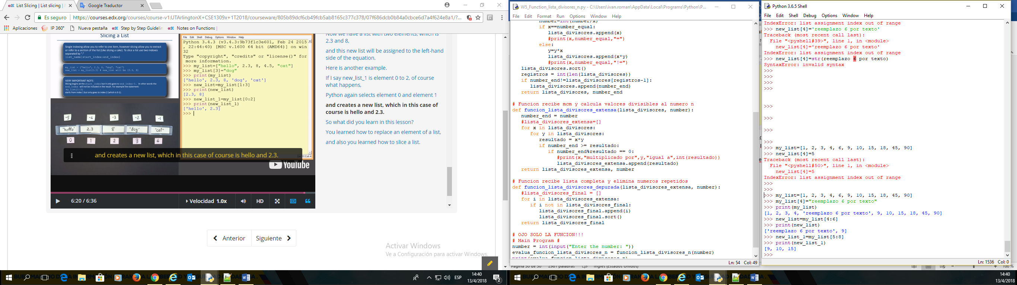

>>> my_list=[1, 2, 3, 4, 6, 9, 10, 15, 18, 45, 90]

>>> my_list[4]="reemplazo 6 por texto"

>>> print(my_list)

[1, 2, 3, 4, 'reemplazo 6 por texto', 9, 10, 15, 18, 45, 90]

>>> new_list=my_list[4:6]

>>> print(new_list)

['reemplazo 6 por texto', 9]

>>> new_list_1=my_list[5:8]

>>> print(new_list_1)

[9, 10, 15]

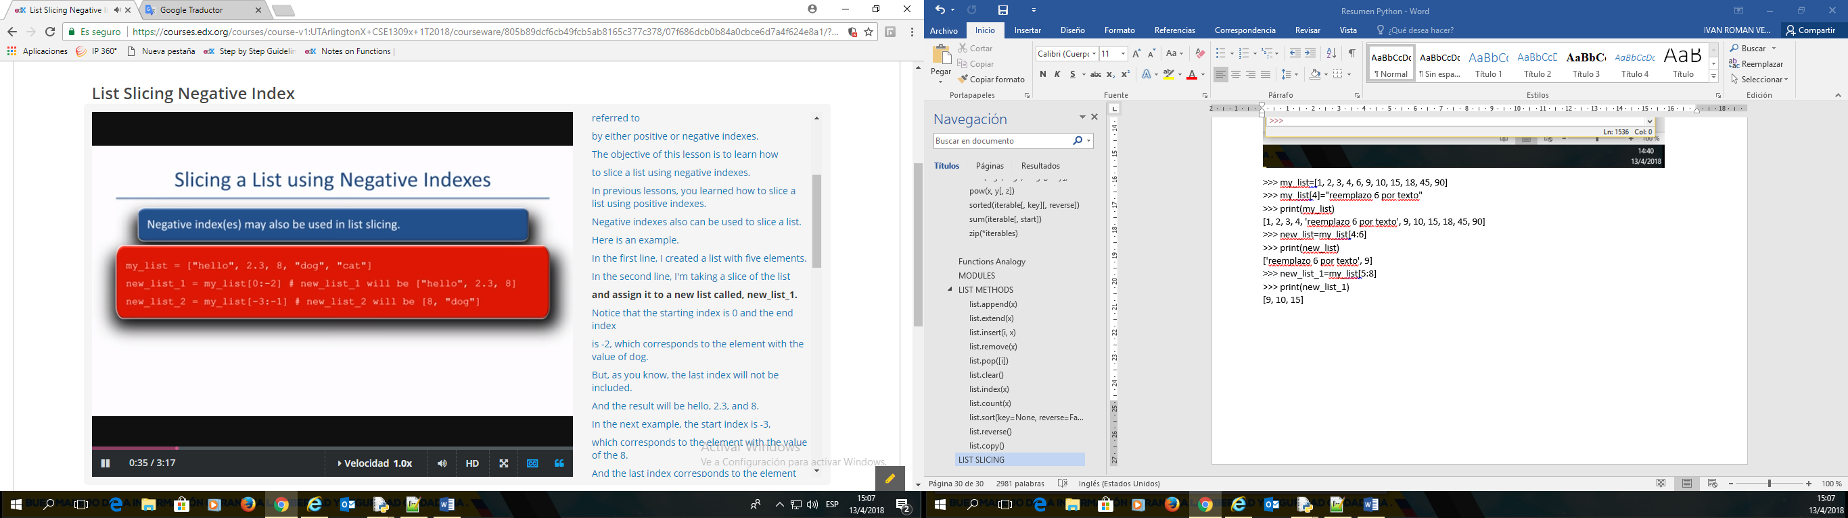

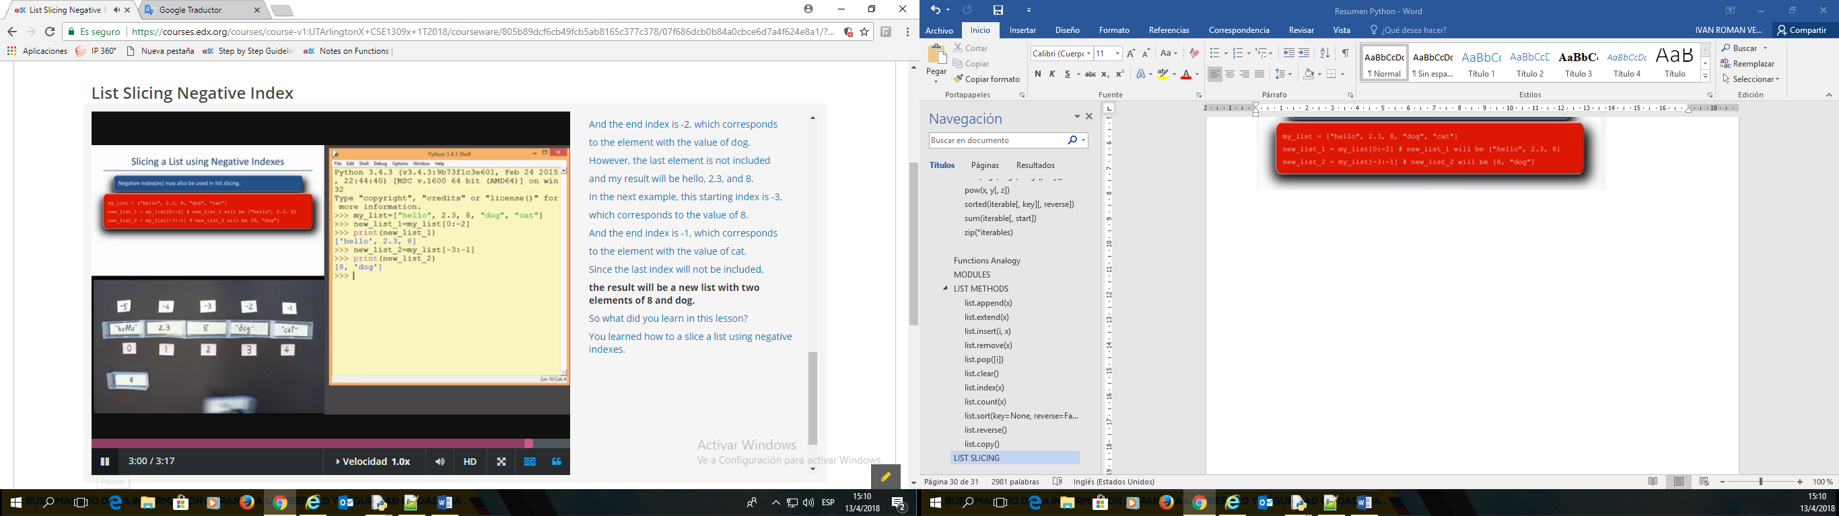

>>> my_list=[1, 2, 3, 4, 6, 9, 10, 15, 18, 45, 90]

>>> new_list_1=my_list[0:-4]

>>> print(new_list_1)

[1, 2, 3, 4, 6, 9, 10]

>>> new_list_2=my_list[-6:-2]

>>> print(new_list_2)

[9, 10, 15, 18]

>>>

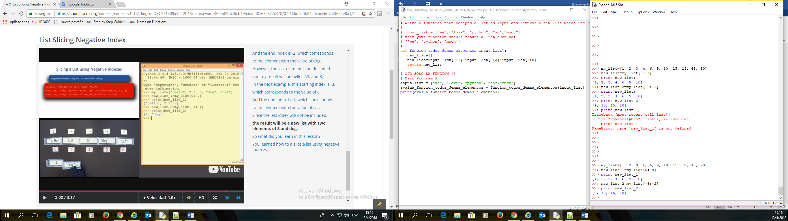

## List Slicing With Step

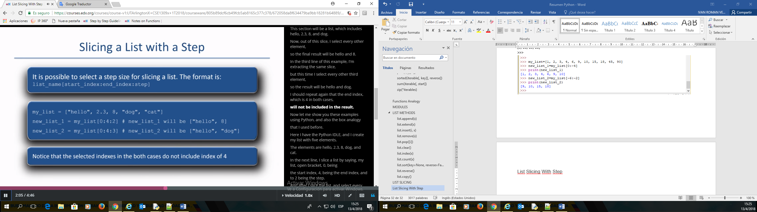

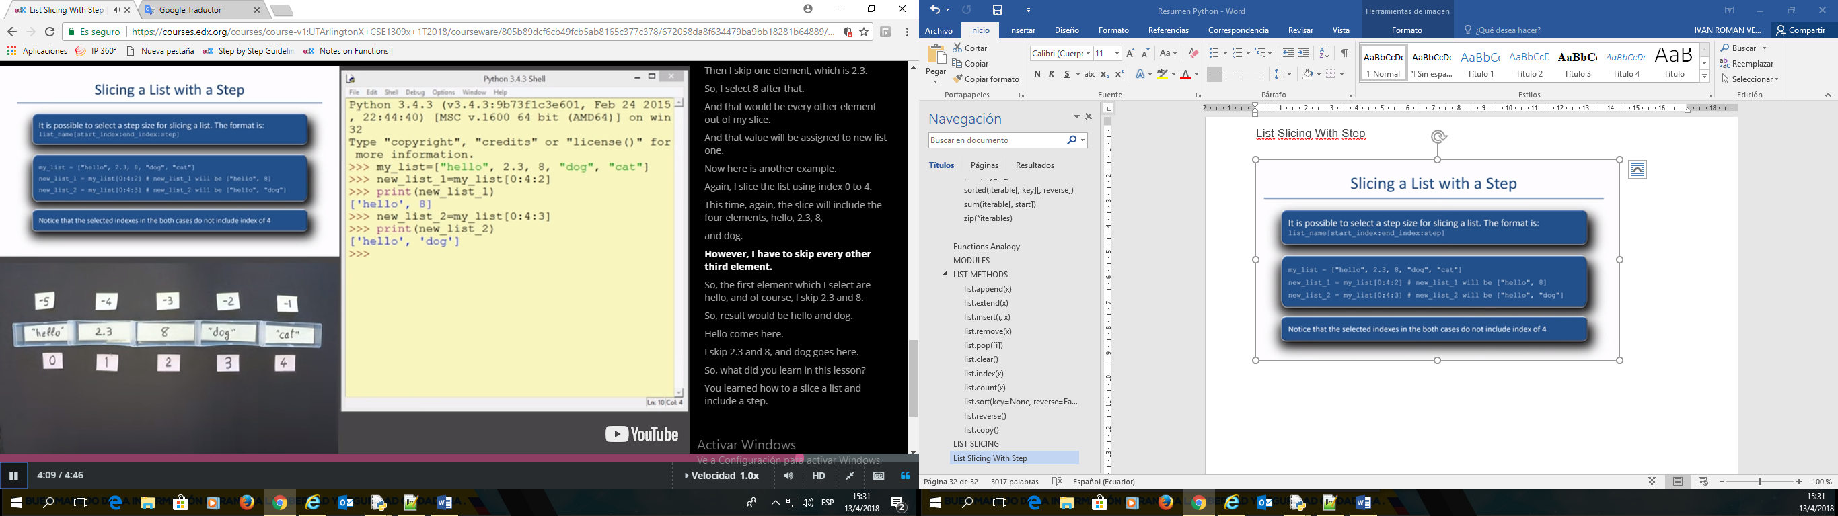

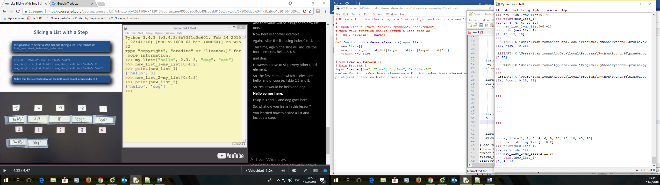

>>> my_list=[1, 2, 3, 4, 6, 9, 10, 15, 18, 45, 90]

>>> new_list_1=my_list[1:10:2]

>>> print(new_list_1)

[2, 4, 9, 15, 45]

>>> new_list_2=my_list[2:11:3]

>>> print(new_list_2)

[3, 9, 18]